[FromBody], [FromQuery], [FromRoute] ASP.NET Core mein **data receive karne ke sources** batate hain.

**🔹 1. [FromBody]**

**[FromBody]** ASP.NET Core ka attribute hai jo HTTP request body se JSON data ko model object me bind karta hai

👉 Data **HTTP request body** se aata hai (mostly JSON format).  
✅ Use in: **POST**, **PUT** requests.

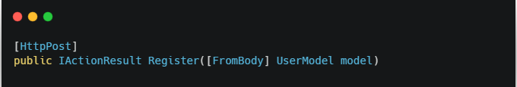

🧠 **Real-world:**  
Jab aap form ya frontend (React, Angular) se JSON bhejte ho.

### 🔸 Bina [FromBody] ke:

Agar [FromBody] na likhen, to ASP.NET confuse ho sakta hai ki data body se lena hai ya query string se.

**🔹 2[FromQuery] –** **URL ke query string se data**

👉 Data **URL query string** se aata hai.  
✅ Use in: **GET requests**.

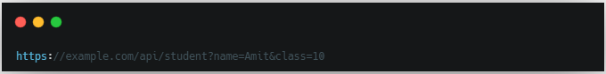

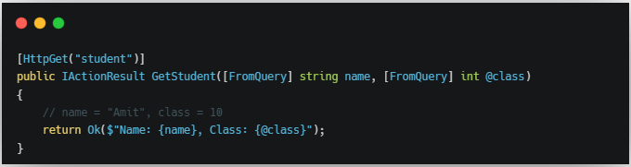

🧠 **Real-world:**  
GET /api/search?name=Ali

**🔹 3.** [FromRoute] – **URL ke path se data**

👉 Data **URL route** se aata hai.  
✅ Use in: URL pattern-based request.

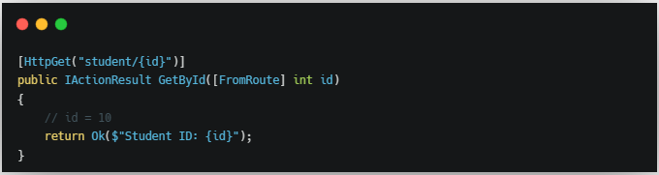

### 🔗 Example URL:

[**https://example.com/api/student/10**](https://example.com/api/student/10)

**🔹 3. [FromForm]**

[FromForm] attribute **HTML form se aane wale data** ko receive karne ke liye use hota hai.

👉 Ye **multipart/form-data** ya **application/x-www-form-urlencoded** data ko handle karta hai.

### **Kab Use Karein?**

✅ Jab aap:

* HTML form se data bhej rahe ho
* File upload kar rahe ho
* Plain form fields use ho rahe hain (na ki JSON)

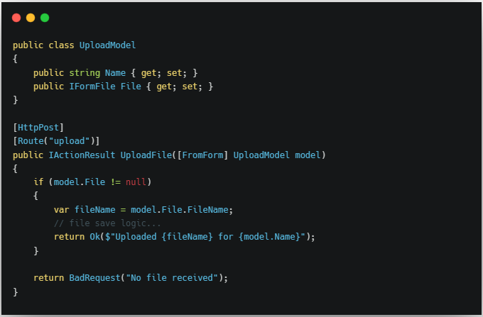

[FromForm] ka use **HTML form data** ya **file upload** handle karne ke liye hota hai — mostly jab **client side** (like HTML form ya Postman) se multipart/form-data bheja jaata hai.

### 🔹 Use Case: [FromForm] in Web API

#### ✅ **Jab Client** multipart/form-data **bhejta hai:**

* HTML Form
* File upload (image, PDF, etc.)
* Postman se file + fields bhejna

### ✅ When to Use Which:

| **Attribute** | **Content-Type** | **Common Use** |
| --- | --- | --- |
| FromBody | application/json | JSON data from the frontend app |
| FromForm | multipart/form-data | HTML forms, file upload |

**✅ Summary Table Updated:**

| **Attribute** | **Source** | **Used In** | **Example** |
| --- | --- | --- | --- |
| FromBody | HTTP request body | POST/PUT | { "name": "Ali" } |
| FromQuery | URL query string | GET | /api/users?name=Ali |
| FromRoute | URL path | GET/DELETE | /api/users/123 |
| FromForm | HTML Form fields | POST | <input name="name">, file upload |

## 🔚 Summary – Ek Table me:

| **Attribute** | **Source** | **Example URL/Data** |
| --- | --- | --- |
| [FromQuery] | Query String | /api?name=Ali |
| [FromRoute] | URL Path | /api/student/10 |
| [FromForm] | HTML Form Body | <form method="post"> |
| [FromBody] | Raw JSON Body | { "name": "Ali" } (in POST/PUT request) |